English Grammar(Solutions)

POSTER MAKING
Question 1. Your school, Kendriya Vidyalaya, Burdwan is going to organise a Diwali Mela. Design a poster to inform the students about various activities connected with it. Ask them to participate in the Mela. You are Divya/Dewan.
Answer:
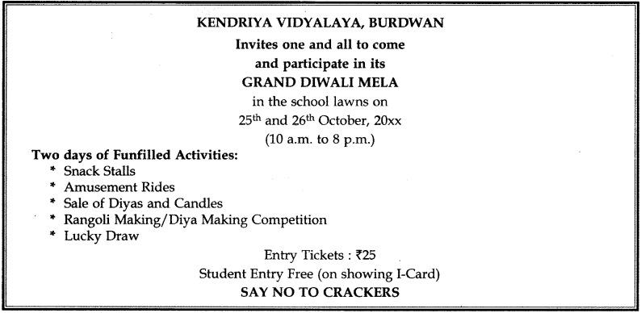
Question 2. As President of Lion’s Club of Vasundhra City, design a poster in not more than 50 words for . promoting good health through ‘Health Mela’ to be held at Central Community Hall of the city. Mention some of its attractions.
Answer:
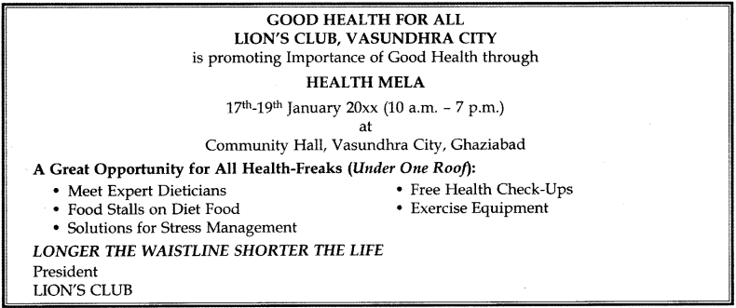

Question 3. As President of the Residents Welfare Association of Mayur Colony, Delhi, design a poster in not more than 50 words for promoting cleanliness in the surroundings of your colony.
Answer:
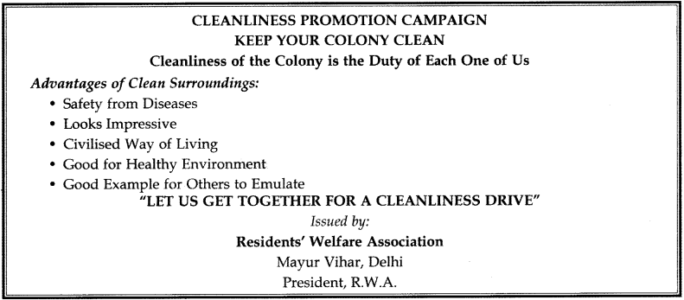
Question 4. Prepare a poster in not more than 50 words on kindness to animals to be displayed in the city at public places appealing to people to show kindness to animals. You are Secretary of the Society for Prevention of Cruelty to Animals, Delhi.
Answer:
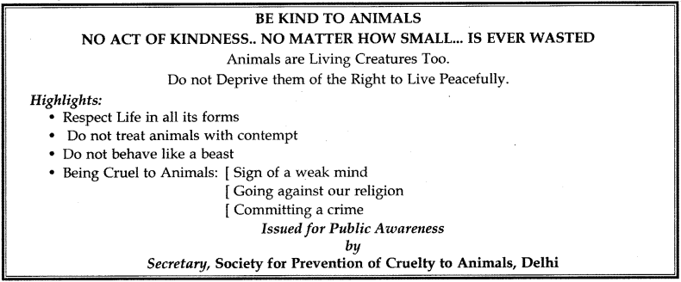
Question 5. You were very upset about the reports on communal riots in various parts of the country. As a concerned social worker, design a poster in not more than 50 words, highlighting the importance of communal harmony. You are Vinay/Vineeta.
Answer:
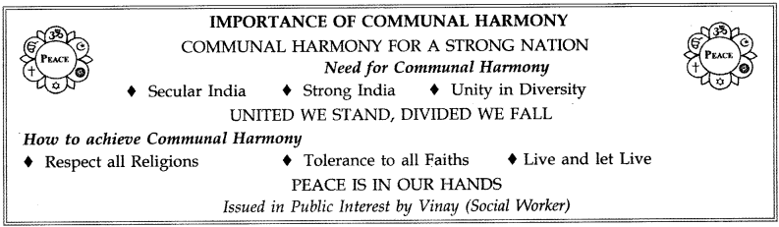

Question 6. You are a member of the S.P.C.A. Draft a poster in not more than 50 words, to create awareness on the need to prevent cruelty to animals. You are Suhas/Suhasini.
Answer:
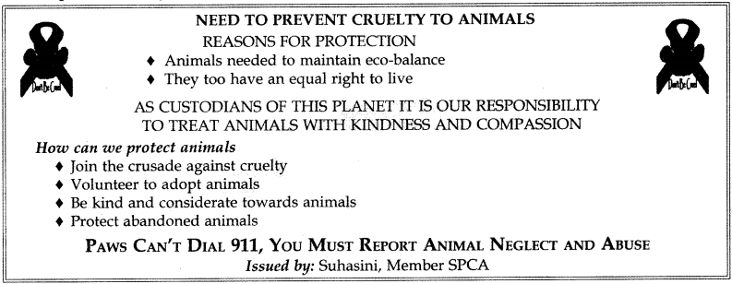
Question 7. You are a fitness trainer in a health club. Design a poster in not more than 50 words, to emphasize the importance of exercise in maintaining mental and physical fitness. You are Prem/Priya.
Answer:
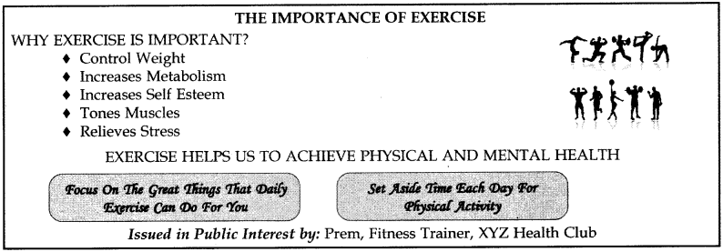
Question 8. Fireworks and crackers are known to create pollution during festivals. As an environ-mentalist design a poster in about 50 words to create awareness of their ill effects.
Answer:
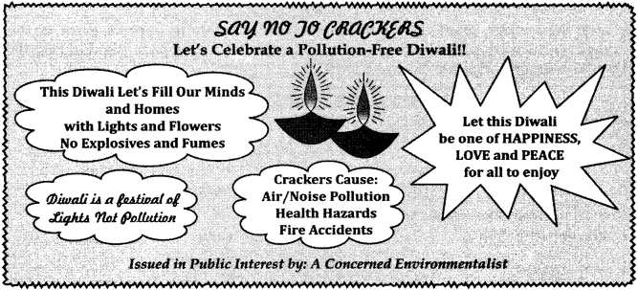

Question 9. Design a poster in about 50 words to create awareness among the people of your city on the importance of following traffic rules.
Answer:
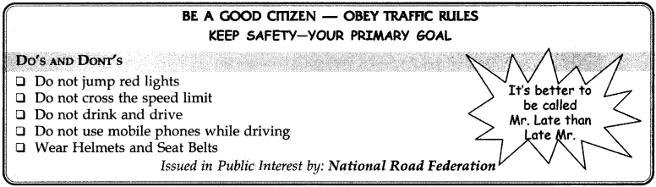
Question 10. Your school is going to organise a Diwali Mela. Design a poster to inform the students about it (50 words).
Answer:
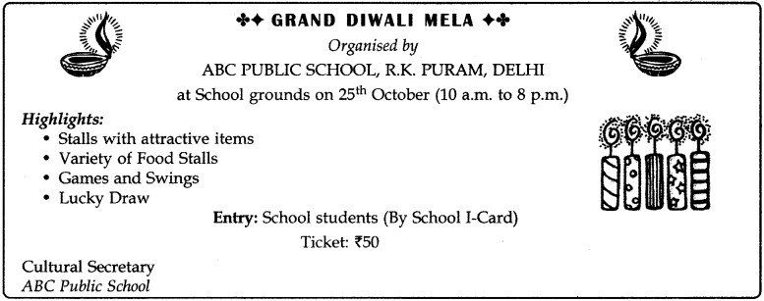
Question 11. Draw a poster on the importance of cleanliness in our life.
Answer:
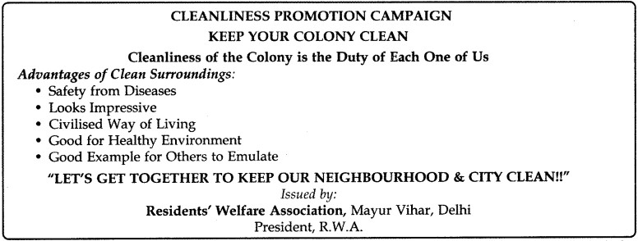

Question 12. Open drains are death traps, risky for old persons and children. They are also breeding grounds for rats, cockroaches etc. Design a poster highlighting the danger of open drains.
Answer:
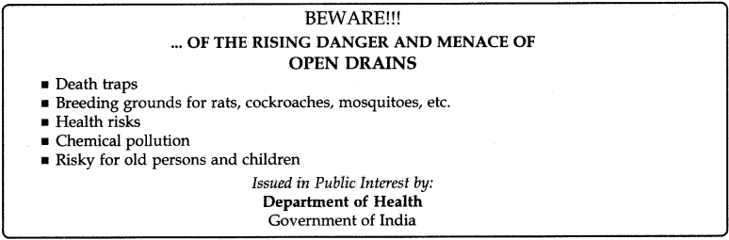
Question 13. Publicly we proclaim that dowry is an evil. Privately we want out sons to fetch good dowries. Right from our school days we should be taught that demanding and even giving dowry is not only illegal but immoral too. Draw a poster in about 50 words highlighting dowry as a curse. You are Vikram/ Sonia.
Answer:
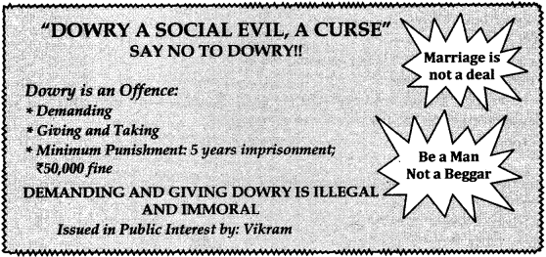

visit:- www.charicoaching.com

